**Brac University Student Honor Code**

On this exam, I will not cheat, use unfair means, join intentionally or unintentionally any online or offline group in which exam answers are posted or discussed, or engage in any behavior that would commonly be deemed to be academically unethical. I will immediately notify the course teacher of any such activity or online or offline groups that I become aware of.  I acknowledge that I may be suspended or expelled from Brac University if I am found to have engaged in any academically unethical behavior.

I understand that a certain percentage of students will be randomly selected for a viva after the exam and asked about their exam answers and related information and that if called for a viva, that I must appear for the viva within a designated time frame. I understand and accept that the viva may be scheduled at any point in time after I submit my answers online.  I may be contacted at the email address listed below for a viva. I understand that a failure to appear for the viva after being notified at the email address below will be considered as evidence of cheating.  An inability to explain my exam answers during the viva may also be considered as evidence of cheating.

I consent to video/audio recording of these viva sessions. I  further recognize that non-compliance with the above may lead to further disciplinary actions that I will be ready to accept without complaint.

______________Shadab Iqbal______________________

Digital Signature

___9.8.2020___________________________________

[shadabiqbalmu@gmail.com](mailto:shadabiqbalmu@gmail.com)

____________________________

Contact Email for Viva

01625960408

_________________________

Contact Phone Number where I can be Reached by SMS

**BRAC University**

**BRAC Business School**

**BBA Program**

**Summer Semester: 2020, Mid-term Examination**

**Course Code: BUS 101, Course Title: Introduction to Business**

**(Section: 8)**

**Marks: 20 Time: 65 Minutes**

**Name: Shadab Iqbal**

**ID: 19101072**

**Note: Zero Tolerance for Plagiarism Save the file under your name and ID in the folder. If you face any difficulties during exam, find me in your fb page.**

**Part A [Mandatory to answer all the question in this part]**

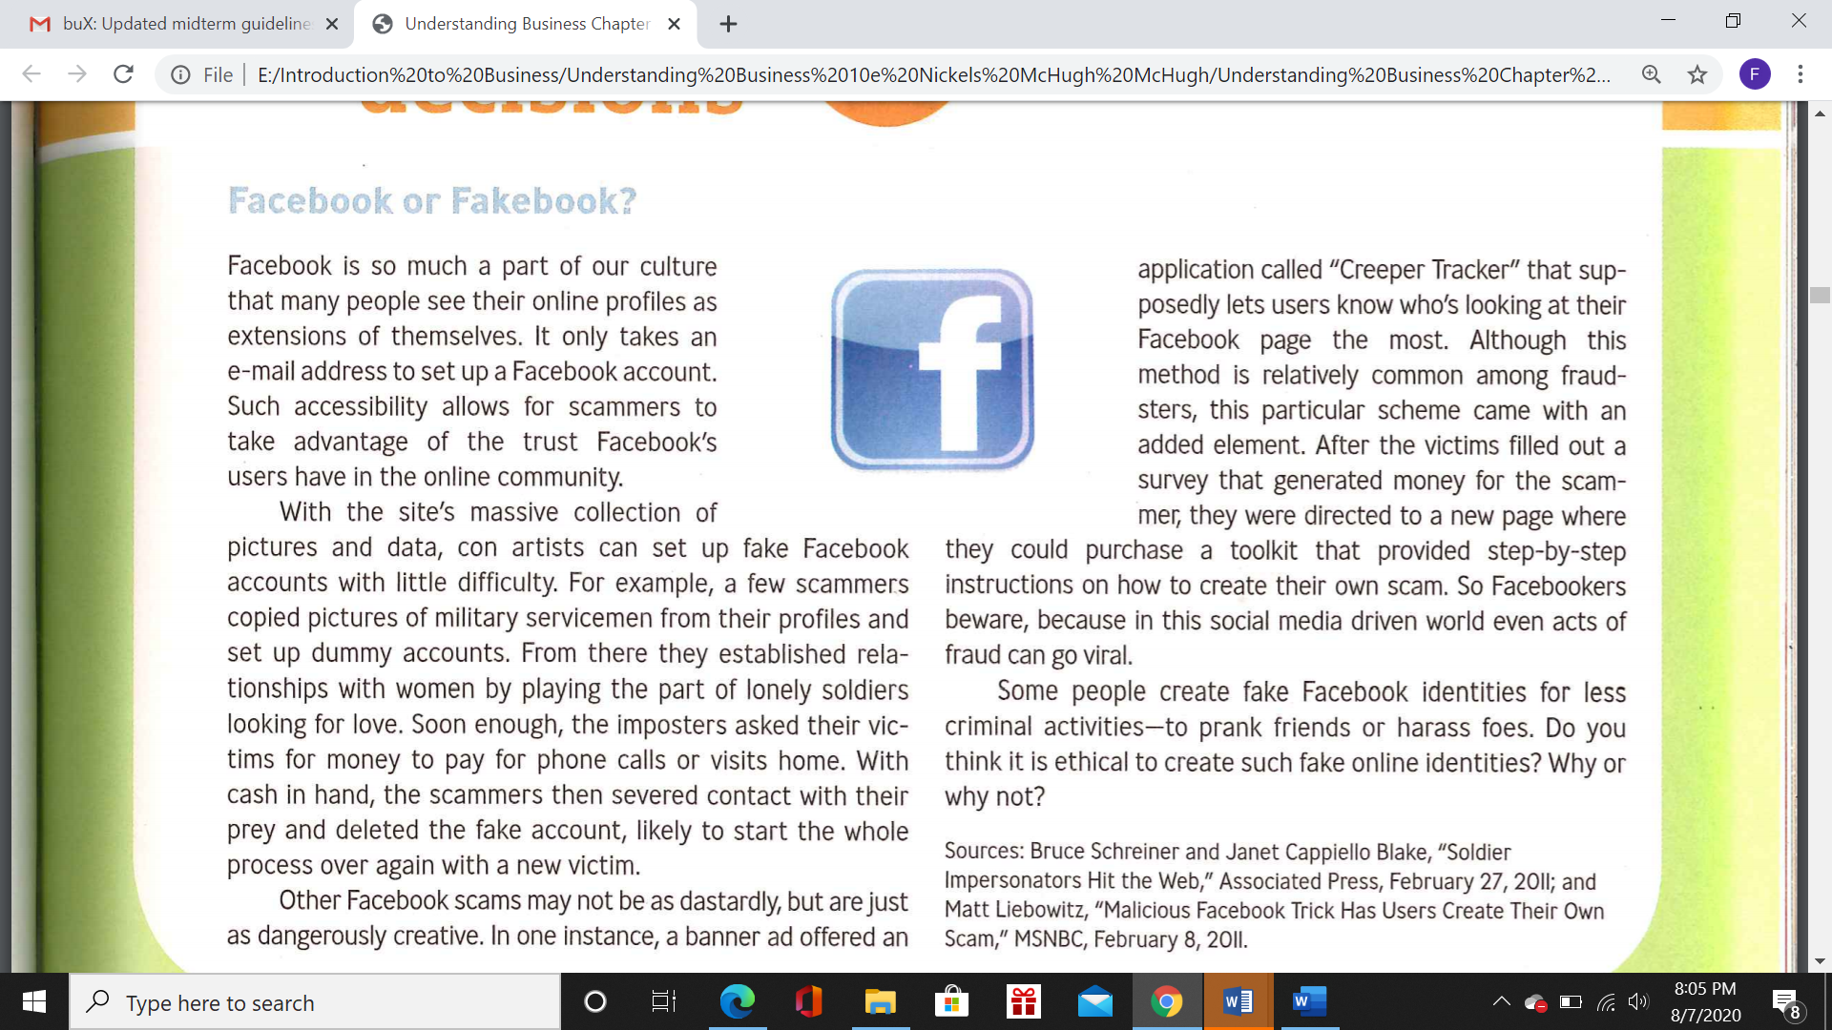

1. Do you think it is ethical to create fake online identities? Why or why not? (3)
2. How ethics is different from legality? Explain with real life examples. (2)

**Part B (Answer any three) [3*5 Marks =15 Marks]**

1. “All the stockholders are stakeholder, but all the stakeholders are not stockholders” Justify the statement with examples. (5)
2. Using diagrams, explain the concept of equilibrium point. Elaborate the concept of surplus and shortage with real life examples. (2+3)
3. Draw the diagram of Dynamic Business Environment. Discuss the factors of the environment from the perspective of Ride sharing industry (e.g Uber, pathao) (1+4)
4. Suppose you are a franchisee located at Dhaka, Bangladesh, you want to buy a franchise, discuss five aspects that you will analyze before buying a global franchise. Why do you think these aspects are essential to do business in your country? (2+3)

**Answer To The Question No. Part A (1)**

In my opinion, it’s completely unethical to create fake online identities.

**Reasons:**

First of all, the amplification of popularity or disliking of a person can be done using fake accounts which will then distort the user views of true public statement. Many obnoxious people are using fake account to disseminate distrust and division in many areas of the world and they are agitating violence against groups or individuals. Also using fake account, many unpleasant individuals are exposing others’ private matters and thus causing immense damage to a whole lot of people.

Furthermore, fake accounts also pose a threat to a business. If monetization is considered, the value of the company is lessened. Again, investors will feel reluctant for a non-quality lead which has almost zero probability of visiting the site again. Also, signups lose their essence unless they’re going to be engaging and active ones. If a user is hoping to have some interaction with a real account on that site and instead he/she encounters an unreal one, reputation will be greatly hampered. Lastly, legal problems can also arise including copyright problems over scraped images and data.

**Answer To The Question No. Part A (2)**

|  |  |
| --- | --- |
| LAW | ETHICS |
| A set of guidelines governing the society and nation as a whole | A set of moral values governing a person’s behavior. |
| Punishable offence | Generally, no punishment |
| Common for mass population | Learns from family, society, institution |
| Written set of rules | Abstract |
| Mainly for establishing peace and prosperity in a nation | Guidelines about how one should behave with another and being able to differentiate between right and wrong. |

**Real life Example:**

The case of abortion. It is legal but not completely ethical. Because, here comes a contradiction about “killing a soul”. It’s more of a complicated issue but it’s immoral in this sense that many don’t want to sanction legalized killing.

**Answer To The Question No. Part B (1)**

All the stockholders are stakeholder, but all the stakeholders are not stockholders”

**Stockholders:**

A stockholder is an individual or organization that owns shares in a corporation. The foremost interest of a stockholder is profitability of the business or project. For having a higher share of profits and dividends, stockholders generally intent to produce huge revenues from the business.

Stockholders can buy or sell their shares, receive dividends, vote and nominate during election of the members of board. They also play a role in the decisions of merging and acquisitioning. Unlike stakeholders, stockholders’ primary focus is the company’s profitability.

**Stakeholders:**

A stakeholder can be an individual or a group that can have an impact or be impacted by the projects and objectives of respective organization. Stakeholders can both be internal or external of the organization.

Internal stakeholders possess a straight cut relationship with the company through investment or ownership. Among them, shareholders, managers, project coordinators are mentionable examples.

On the other hand, external stakeholders are the ones which don’t have a direct association but can impact or be impacted by the company’s actions. Suppliers, consumers, customers, contractors, creditors etc. can be considered as some examples of external stakeholders.

Stakeholders can be stockholders of a company, but not all stakeholders are stockholders. For example, “owner” is not only a stakeholder but also a stockholder of the company as he affects and get affected by the company. Again, “environment” can be considered as one of the stakeholders of a company as it impacts and gets impacted by the company, but it under no circumstances can be called a stockholder as it doesn’t operate for profit.

**Answer To The Question No. Part B (2)**

Price

Surplus

Orange line = Supply

Equilibrium Point Green line = Demand

Shortage

Quantity

**Surplus:**

Surplus means excess supply. It’s a scenario in which the amount of producers trying to sell doesn’t match the amount of customers wanting to buy that product. Whenever there is a surplus, price will keep dropping till the surplus goes away. For example, the price of a gallon of gasoline. Imagine it is sold at 150 tk per gallon. At this price, the demand is suppose 500 gallons but the supply amount is 700 gallons. So there are 200 gallons more being produced which is not needed. This kind of scenario is known as surplus.

**Shortage:**

Shortage means excess demand. If we go back to our gasoline example, if the demand is now 1000 gallons instead of 500, and the supply remains the same 700 gallons, this will create a shortage of gasoline situation. In this type of scenario, the price keeps getting higher until the supply demand difference is not lessened.

**Answer To The Question No. Part B (2)**

**Five aspects that I will analyze before buying a global franchise and why they are important to do business in this country:**

1. **Demand:** The best way to start a business is to understand the market and their demands. I have to be wary that what sells well in other countries may not be equally well-received here. So sufficient amount of researches should be done first. The potential for expansion should also be considered if I intend to branch out to multiple outlets in the future.
2. **Expenditure:** The second thing to know is the total investment to get my franchise up and running.Understanding the costs of purchasing, opening inventory and the amount of working capital I am going to need, should be kept in mind as I don't want to run out of money when I am on the verge of success.
3. **Tracking:** Thanks to the power of the Internet, it’s not difficult to find out a lot about people and companies, so I should start by making sure that the franchisor I’m about to do business with has solid experience. I also have to track their record, their growth in the market, their value and their reach. It is very important to understand the business well and their track record better because having a franchising doesn’t mean they are a successful brand.
4. **Training:** A major advantage of franchising is the training and support offered to franchisees. If I don’t have any entrepreneurial experience, then it is advisable to choose a franchise that offers substantial training. This is the first step to a successful business. The franchise who offer essential training and guide at every step are the best brands to take franchisee of.
5. **Restrictions:** It is very common for franchisors to impose certain restrictions on how their franchises are to be run. They usually require franchisees to follow guidelines and standards which may encompass things such as product offerings, prices, operational hours, and store design among others. A franchise is much different than what it looks, it is always better to research deep before choosing a business type and starting my own.

These are the five aspects I should consider before buying a franchise in my country. Because the market environment of South Asia is somewhat different than Europe, America etc. So, I should be careful in these factors, otherwise my whole investment will go into vain for nothing. BD is such a country where every goods is not acceptable by the society. So I have to be aware of the demand of the product I am wanting to buy franchise of. Then expenditure must be kept in mind as Bangladesh is still a developing country. Also, record tracking should be done properly as our country is sensitive in this matter. Proper training is also a must because we need to fully utilize our manpower. Lastly, restrictions should be considered as many of abroad companies have a tendency to dominate developing countries like ours.